Ocean Lu  
CS 4650.01  
Professor Yang  
10/22/19

Assignment #5: Lab Report

Task 1:

The editor I used was AWS Cloud9: <https://aws.amazon.com/cloud9/>, which gives me the flexibility of running my development server on a managed Amazon EC2 or any existing Linux server that supports SSH. I wrote, ran, and debugged applications with just a browser—no local IDE.

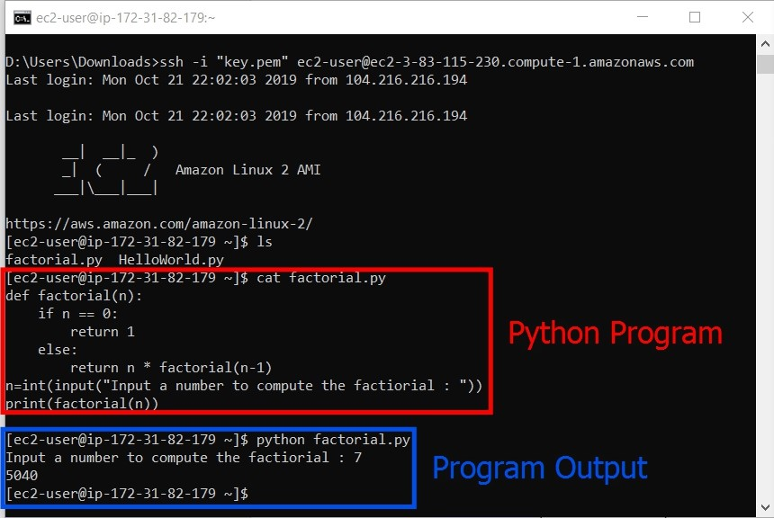

Task 2:

CPP Weblink: <https://www.cpp.edu/~oslu/>

EC2 Weblink: <http://ec2-3-83-115-230.compute-1.amazonaws.com/>